Contents
Overview 4
Features 4
Plug-in Connections 5
How Turn-O-Matic systems work 6
V3 system configurations and features 7
S3 base systems 7
S3 expansions, hard-wired Push Button 8
S3 expansions, wireless Push Button 9
M3 base system 10
M3 expansions 11
M3 Par (parallel service points) 12
M3 Par expansions 13
M3 Par expansion option – SP Indicators 14
M3 Par expansion option – SL900 service position lamps 15
L3 base system 16
L3 expansions 17
L3 multiple services 18
L3 Par (parallel service points) 19
L3 Par expansion option – SP Indicators 20
L3 Par expansion option – SL900 service position lamps 21
L3 expansion options – info Indicators 22
L3 Par expansion option – service position help call Indicator 23
V3 installation, connections and address setting 24
Power connections 24
I/O connections 25
Setting TOM-Net addresses 26
V3 installation, TOM-Net address settings 27
S3 base systems, address settings 27
S3 expansions, hard-wired Push Button, address settings 28
S3 expansions, wireless Push Button, address settings 29
M3 base system, address settings 30
M3 expansions, address settings 31
M3 Par (parallel service points), address settings 32
M3 Par expansions, address setttings 33
M3 Par expansion option – SP Indicators, address settings 34
M3 Par expansion option – SL900 service position lamps, address settings 35
L3 base system, address settings 36
L3 expansions, address settings 37
L3 multiple services, address settings 38
L3 Par (parallel service points), address settings 39
L3 Par expansion option – SP Indicator, address settings 40
L3 Par expansion option – SL900 service position lamps, address settings 41
L3 expansion options – info Indicators, address settings 42
L3 Par expansion option – service position help call Indicator, address setting 43
Approximate installation times for V3 START and PLUS packs 44
V3 system messages 45
Indicator error messages 45
K900 error messages 46
K900 warning messages, L3 system 47
V3 products in V2 system configurations 49
Direct 900 – replacement Indicator 49
Direct 900 – expansion Indicator 50
Direct 900 Parallel – replacement Indicator 51
Direct 900 Parallel – expansion Indicator 52
Select 900 – replacement Indicator 53
Select 900 – expansion Indicator 54
Select 900 – K900 replacement for C900 55
Select 900 Parallel – replacement Indicator 56
Select 900 Parallel – K900 replacement for C900 57
Select 900 Parallel – expansion SP Indicator and K900 58
Signal and Info 900 – D900A3 replacement for D900A or D90E 59
Signal and Info 900 – replacement Indicator 60
Signal and Info 900 – K900 replacement for C900 61
Signal and Info 900 Parallel – expansion SP Indicator and K900 62
Signal and Info 900 – expansion with K900 63
Connection adapter V2 cable - V3 RJ10 plug, pin out 64

Overview

Features
Turn-O-Matic V3 products and systems were developed to improve and expand the current V2 range with new features, cost savings and quality improvements while retaining the best current features. Major new features across the V3 product line are:

- Simple, plug-in installation for lower installed costs
- Improved, more tolerable electronics for lower warranty and service costs
- Small S3 system; low cost plug&play sequential service system with top of the line features
- Medium M3 system; deluxe features at low cost for sequential or selected service at up to 15 parallel service points
- Large L3 system; competitive multiple service alternative (up to 5 service types) with real-time and statistical data information for service at up to 30 parallel service points.

Still retaining the most valuable V2 features:
- Safe, low-voltage units
- Modular products for flexible system configuration
- Simple, reliable 2-wire data transmission allowing networks over 500 meters long

Plug-in Connections
All V3 units have plug-in connection ports, type DC jack and RJ10 jack.


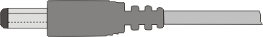

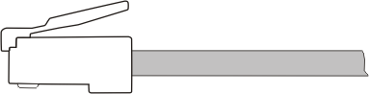
DC jack
2.5 mm
Mating connector: DC plug 2.5 mm
Connection for power:
All units, 12VAC or 15VDC
RJ10 jack
(4P4C) mm
Mating connector: RJ10 plug
Connection for data: All units
Connection for Push Buttons in S3 system
Connection for Indicator cascade
NOTE: Plug-in data cables are not designed to be field-fabricated. Original Turn-O-Matic plug-in mating cables must be used to ensure proper connections and system operation.

CAUTION: There is no standard for DC jack & plug tolerances and not all DC plugs will fit correctly into the DC jacks on TOM units. DO NOT USE A DC PLUG THAT MATES TOO TIGHTLY AND MUST BE FORCED INTO THE PLUG AS THIS WILL DAMAGE THE TOM UNIT AND VOID THE WARRANTY.

How Turn-O-Matic systems work
Every system with more than one electronic unit (Indicator, K900, SL900, D900A3 or SC900) is a data network, type RS485 using a Master-Slave communications protocol. Each TOM unit includes an RS485 transceiver for receiving and transmitting digital data, with 2 data ports for plug-in linking on the Turn-O-Matic network (TOM-Net) as a serial chain, typically called a ‘daisy chain’ as illustrated below.

In addition to the data connections shown, each TOM-Net unit requires power; 12VAC or 15VDC.
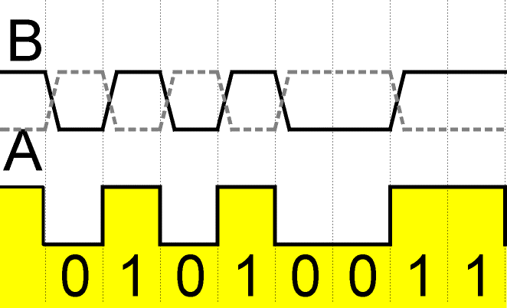
SLAVE
SLAVE
SLAVE
SLAVE
MASTER
TOM-Net data cable
Plug-in terminators
on end units to prevent data echoes.
Only one MASTER per system, can be in any position on the chain.
TOM-Net total length can be 610 m (2000 ft).
Maximum number of network units per system = 256 for V3 (32 for V2).
The MASTER sends queries and commands to SLAVE units and input SLAVE units respond to queries with digital data on the 2-wire TOM-Net by changing the relative voltage between lines A and B. When V_{A} < V_{B}, the data is a binary 1 and when V_{A} > V_{B}, the data is a binary 0.
The V3 TOM-Net data transmission rate is 19200 bps (bits per second) and the V2 data rate is 4800 bps.

The importance of using proper data cabling:
The RS485 data circuit can be affected by the increasing amount of interference present in today’s environment; electromagnetic (EMI), electrostatic (ESI) and radio frequency (RFI) interference. To minimise the interference effects, Turn-O-Matic data cable is shielded, twisted pair, type LiY-CY, min. size 2 x 0.14 mm (26 AWG). To provide a continuous reference ground for the RS485 data signal, the cable shield is also used as a signal ground and is connected at each unit.

Using a lower quality cable for TOM-Net data cable or making lower quality connections may work without problems in some installations, but never in all installations.

V3 system configurations and features


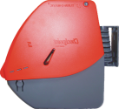
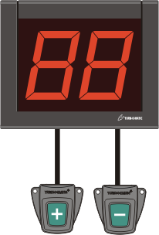
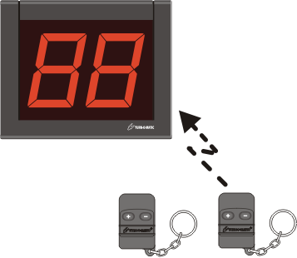
S3 base systems
Indicator INR902
Dispenser D900

Counter Stand
(CS) optional
START pack S32 PB CS
Push Button PB900 (-)
Push Button PB900 (-)
Wireless Push Button RFv2
Indicator INR902 RF
Dispenser D900

Counter Stand
(CS) optional
START pack S32 RF CS
Hard-wired Push Button
Wireless Push Button
START packs with 3-digit Indicator INR903 optional.

Indicator power supply not shown.

- Set starting service number; take a ticket from dispenser and set Indicator display to ticket number. Hold down Push Button (+) to increase displayed number +10, press once to increase number +1, press Push Button (-) to decrease number –1.
- Service turn reservation; arriving customers take sequentially numbered ticket from dispenser.
- Call customers for service; press Push Button (+) to increase displayed service number on Indicator +1.
- Indicator saves last displayed number in non-volatile memory on power OFF and displays saved number on new power ON.
- Indicator display flashes on number change +1; number of flashes is set-up selectable from 0 = no flashing to 9 = continuous flashing.
- Indicator sounds a tone on number change +1; tone type and volume is selectable via dip switches on back of Indicator.
- Indicator display update can be delayed on multiple Push Button presses; display update is set-up selectable from 0 to 29 seconds.
- Indicator display can shut OFF (SLEEP) on no activity; time to SLEEP is set-up selectable from 0 = No SLEEP to 99 minutes.

S3 expansions, hard-wired Push Button

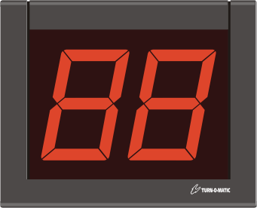
MASTER
Dispenser D900

Counter Stand
(CS) optional
START pack S32 PB CS
Push Button PB900 (-)
Push Button PB900 (-)
TOM-Net
data cable
PLUS pack INR902
SLAVE
PLUS pack INR902
SLAVE
PB900 (+) plug-in set
PB900 (+) plug-in set
Max = 256
Indicators / system
Max = no limit
PLUS packs with 3-digit Indicator INR903 optional.

Indicator power supply not shown.

- Indicator PLUS packs include plug-in Power supply and plug-in TOM-Net data cable.
- Extended display of called service number; PLUS pack SLAVE Indicators display same number as the START pack MASTER Indicator.
- Multiple Push Button input, press any Push Button (+) to increase displayed service number on Indicator(s) +1. Use power ON set-up on MASTER Indicator to set Indicator(s) display update delay on multiple Push Button presses. MASTER Indicator can buffer up to seven (7) Push Button presses.

S3 expansions, wireless Push Button
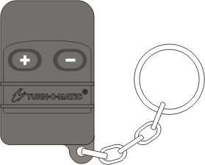
MASTER
Dispenser D900

Counter Stand
(CS) optional
START pack S32 RF CS
TOM-Net
data cable
PLUS pack INR902
SLAVE
PLUS pack INR902
SLAVE
Wireless Push Button
Wireless Push Button RFv2
Max = 256
Indicators / system
Max = 15 PB / system
PLUS packs with 3-digit Indicator INR903 optional.

Indicator power supply not shown.
Wireless Push Button

- Indicator PLUS packs include plug-in Power supply and plug-in TOM-Net data cable.
- Extended display of called service number; PLUS pack SLAVE Indicators display same number as the START pack MASTER Indicator.
- Multiple Push Button input, press any Push Button (+) to increase displayed service number on Indicator(s) +1. Use power ON set-up on MASTER Indicator to set Indicator(s) display update delay on multiple Push Button presses. MASTER Indicator can buffer up to seven (7) Push Button presses.
- Wireless Push Buttons are digitally coded to eliminate cross talk between neighbouring systems. Expansion Wireless Push Button codes must be recorded in the Receiver on the MASTER Indicator to be recognised by the system.

M3 base system
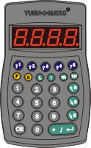
MASTER
Dispenser D900

Counter Stand
(CS) optional
START pack M32 CS
TOM-Net
data cable
START pack with 3-digit Indicator INR903 optional.

Indicator and K900 power supply not shown.
Keypad
K900

- Set starting service number; take a ticket from dispenser and set start number on the K900. Hold down F key 2+ seconds, key in ‘2 0’, press ENTER, key in ticket number, press F to save and exit.
- Service turn reservation; arriving customers take sequentially numbered ticket from dispenser. Alternatively, for order pick-up service, last two digits of customer receipt can be used for selectively calling service turn number when order is ready.
- Call customers sequentially for service; press K900 ENTER key to increase displayed service number on K900 and Indicator +1. To decrease service number, press R key on K900 (no Indicator display).
- Call customers selectively for service; key in number on K900 and press ENTER key to display number on K900 and Indicator.
- Save customers for ‘Repeat Display’; with service number displayed on K900, press S key or use set-up option for ‘Automatic’ saving on calling for service. Up to 20 numbers can be repeated on the Indicator from 0 = no ‘Repeat Display’ to 9 = continuously repeating.
- Remove customer from ‘Repeat Display’; key in service number on K900 and press E key.
- K900 saves last called number in non-volatile memory on power OFF and displays saved number on new power ON.
- Indicator display flashes on number change; number of flashes is set-up selectable from 0 = none to 9 = continuous flashing.
- Indicator sounds a tone on number change; tone type and volume is selectable via dip switches on back of Indicator.
- Indicator display update for multiple K900 entries and ‘Repeat Display’; update delay is selectable from 0 to 29 seconds.
- Indicator display can shut OFF (SLEEP) on no activity; time to SLEEP is set-up selectable from 0 = No SLEEP to 99 minutes.

M3 expansions
Dispenser D900

Counter Stand
(CS) optional
START pack M32 CS
TOM-Net
data cable
Keypad
K900
MASTER
TOM-Net
data cable
PLUS pack INR902
PLUS pack INR902
PLUS pack K900
Max = 241
Indicators / system
Max = 15
K900 / system
PLUS packs with 3-digit Indicator INR903 optional.

Indicator and K900 power supply not shown.
PLUS pack K900

- Indicator and K900 PLUS packs include plug-in Power supply and plug-in TOM-Net data cable.
- Extended display of called service number; PLUS pack Indicators display same number as the START pack Indicator.
- Multiple K900 inputs; press any K900 ENTER key to increase displayed service number on Indicator(s) +1 or call any selected number from any K900. Indicator(s) display update delay on multiple K900 calls is set-up selectable from 0 to 99 seconds. MASTER K900 can buffer up to twenty (20) multiple number inputs.

M3 Par (parallel service points)
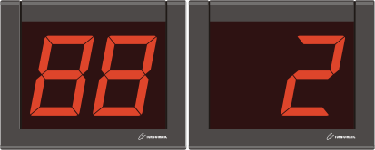
MASTER
Dispenser D900

Counter Stand
(CS) optional
START pack M32 Par CS
TOM-Net
data cable
START pack with 3-digit Indicator INR903 optional.

Indicator and K900 power supply not shown.
Keypad
K900
CDR22
(Customer
Direction display)
SP1
SP2

- Set starting service number; take a ticket from dispenser and set start number on the MASTER K900.
- Service turn reservation; arriving customers take sequentially numbered ticket from dispenser. Alternatively, for order pick-up service, last two digits of customer receipt can be used for selectively calling service turn number when order is ready.
- Call customers sequentially for service; press K900 ENTER key to increase service number +1 and display called service number and calling service point number (SP) on CD display. To decrease service number, press R key (no Indicator display).
- Call customers selectively; key in number on K900 & press ENTER to display service number and SP number on CD display.
- Save customers for ‘Repeat Display’; with service number displayed on K900, press S key or use set-up option for ‘Automatic’ saving on calling for service. Up to 20 numbers can be repeated on the Indicator from 0 = no ‘Repeat Display’ to 9 = continuously repeating.
- Remove customer from ‘Repeat Display’; key in service number on K900 and press E key.
- K900 saves last called number in non-volatile memory on power OFF and displays saved number on new power ON.
- CD display flashes on number change; number of flashes is set-up selectable from 0 = none to 9 = continuous flashing.
- CD display ‘number’ Indicator sounds a tone on number change; tone type and volume is selectable via dip switches on back of Indicator.
- CD display update for multiple K900 entries and ‘Repeat Display’; update delay is selectable from 0 to 29 seconds.
- CD display can shut OFF (SLEEP) on no activity; time to SLEEP is set-up selectable from 0 = No SLEEP to 99 minutes.

M3 Par expansions
MASTER
Dispenser D900

Counter Stand
(CS) optional
START pack M32 Par CS
TOM-Net
data cable
Keypad
K900
SP1
SP2
TOM-Net
data cable
PLUS pack CDR22
PLUS pack K900
Max = 241
Indicators / system
Max = 15
K900 / system
PLUS packs with 3-digit Indicator INR903 optional.

Indicator and K900 power supply not shown.
PLUS pack K900
SP3
SP15 Max

- Indicator and K900 PLUS packs include plug-in Power supply and plug-in TOM-Net data cable.
- Extended display of service number and calling SP number; PLUS pack CD Indicators display same numbers (called service number and calling SP number) as the START pack CD Indicators.
- Multiple K900 inputs; press any K900 ENTER key to increase displayed service number on Indicator(s) +1 or call any selected number from any K900. Use function setting F33 to set Indicator(s) display update delay on multiple K900 calls. MASTER K900 can buffer up to twenty (20) multiple number inputs.

M3 Par expansion option – SP Indicators
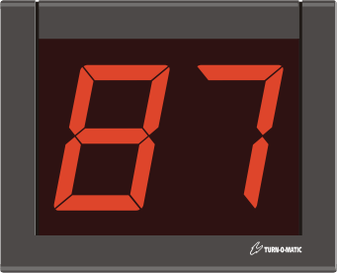
MASTER
Dispenser D900

Counter Stand
(CS) optional
START pack M32 Par CS
Keypad
K900
SP1
SP2
TOM-Net
data cable
PLUS pack INR902
PLUS packs with 3-digit Indicator INR903 optional.

Indicator and K900 power supply not shown.
PLUS pack INR902
SP1
SP2

- Indicator PLUS packs include plug-in Power supply and plug-in TOM-Net data cable.
- Service Point (SP) Indicators display last called service number at the SP. Number remains displayed until the next service call at that SP.
- Inactive service points can automatically shut off their SP Indicator (SLEEP); time to SLEEP is set-up selectable from 0 = No SLEEP to 99 minutes.

M3 Par expansion option – SL900 service position lamps


MASTER
Dispenser D900

Counter Stand
(CS) optional
START pack M32 Par CS
Keypad
K900
SP1
SP2
TOM-Net
data cable
PLUS pack SL900x2
Indicator, K900 and SL900 power supply not shown.
SP1
SP2

- SL900 PLUS pack includes plug-in Power supply and plug-in TOM-Net data cables.
- Service Point (SP) signal lamps guide customers to calling service point. SL900 at calling service point blinks on service call at that SP and then remains steady lit for an additional time. SL900 blink and steady-lit time durations are set-up selectable; blinking time from 0 to 99 seconds and steady-lit time from 0 to 99 seconds.

L3 base system
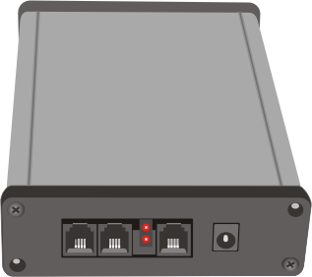
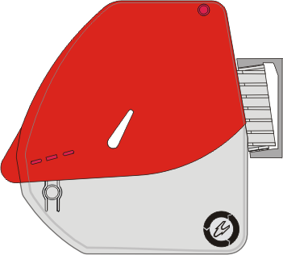
MASTER
Dispenser D900A3
START pack L3
TOM-Net
data cable
PLUS pack with 3-digit Indicator INR903 optional.

SC900, D900A3, Indicator and K900 power supply not shown.
Keypad
K900
System Controller SC900
PLUS pack D900A3
PLUS pack INR902
PLUS pack K900

- Indicator, D900A3 and K900 PLUS packs include plug-in Power supply and plug-in TOM-Net data cable.
- Set starting service number; take a ticket from dispenser with cover open and set start number on the K900 after it is logged on.
- Service turn reservation; arriving customers take sequentially numbered ticket from dispenser, which automatically registers the ticket in the SC900 and presents the next ticket.
- Customers waiting info; pressing the ?W key on the K900 displays number of customers waiting.
- Call customers sequentially for service; press K900 ENTER key to increase displayed service number on K900 and Indicator +1. If there are no waiting customers, K900 displays - 0 - and does not increase the service number.
- Priority call customers for service; key in number on K900 and press ENTER key to display number on K900 and Indicator.
- Save customers for recall; press S key on the K900 or use set-up option for ‘Automatic’ saving.
- Recall saved customers; press R key on K900 to scroll recall numbers and press ENTER to recall or key in recall number and press R key.
- Service transaction data; SC900 saves date and time when ticket number was dispensed, called for service and when service was completed. This data can be uploaded using the included Turn-O-View 3 software to view and print service statistics.
- Mark customer type; press ?1 ... ?5 key on K900 to mark customer or inquiry type, including marking NO SHOW customers.
- Indicator display flashes on number change; number of flashes is set-up selectable from 0 = none to 9 = continuous flashing.
- Indicator sounds a tone on number change; tone type and volume is selectable via dip switches on back of Indicator.
- Indicator display update for multiple K900 service calls; update delay is selectable from 0 to 99 seconds.
- Indicator display can shut OFF (SLEEP) on no activity; time to SLEEP is set-up selectable from 0 = No SLEEP to 99 minutes.

L3 expansions
SYSTEM
MASTER
SP 1
SP 2
TOM-Net

data cable
Expansion
SL900, SP marking lamps
(max 15 total)
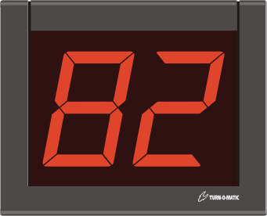
PLUS pack with 3-digit Indicator INR903 optional. SC900, D900A3, Indicator, SL900 and K900 power supply not shown.
Max = 220
Indicators + SL900 / system
MASTER
START pack L3
TOM-Net
data cable
Keypad
K900
System Controller SC900
PLUS pack D900A3
PLUS pack INR902
PLUS pack K900
PLUS pack SL900x2
PLUS pack
K900
Max = 30
K900 / system
PLUS pack INR902
PLUS pack INR902
Recall Service Indicator
HCW Alert Signal
Service Indicator Extension

- Indicator, K900 and SL900 PLUS packs include plug-in Power supply and plug-in TOM-Net data cable.
- Extended display of called service number; PLUS pack Service Indicators display same number as the base PLUS pack Indicator.
- Separate recall service Indicator; a separate Indicator can be used for directing recall service customers to another location or to distinguish recall service from normal service calls.
- Multiple K900 input; press any K900 ENTER key to increase displayed service number on Service Indicator(s) +1 or call any selected number from any K900. Indicator display update delay on multiple K900 calls is set-up selectable from 0 to 99 seconds. MASTER K900 can buffer up to twenty (20) multiple number inputs.
- Customers waiting signal; Help Customers Waiting (HCW) SL900 lamps light up when there are customers waiting for service. SL900 lamps blink when number of waiting customers reaches ‘Alert Signal’ level; selectable from 1 to 99 customers waiting.
- Customer waiting time option; HCW Alert Signal blinking level can be set to customer waiting time, selectable from 1 to 99 minutes waiting or alternatively from 10 to 990 seconds waiting.

L3 multiple services
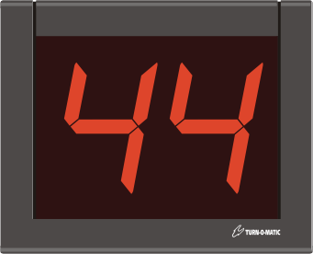
MASTER
START pack L3
TOM-Net
data cable
PLUS packs with 3-digit Indicator INR903 optional. SC900, D900A3, Indicator, SL900 and K900 power supply not shown.
Keypad
K900
System Controller SC900
PLUS pack D900A3
PLUS pack INR902
PLUS pack K900
PLUS pack D900A3
PLUS pack INR902
PLUS pack SL900x2
Service ‘A’
PLUS pack
K900
Max = 30
K900 / system
Max = 5
D900A3 / system
Service ‘B’
Service ‘B’
Service ‘A’
Service ‘A’
Service ‘B’
Max = 220
Indicators + SL900 / system
HCW Alert Signal

- Indicator, D900A3, K900 and SL900 PLUS packs include plug-in Power supply and plug-in TOM-Net data cable.
- Multiple services in parallel; up to 5 ticket dispensers per system, each dispenser for a separate service type.
- Multiple services in series; service ticket numbers can be moved (saved) to the next available service type slot (without dispenser) for continuing service. The receiving service type can then move service numbers to a third service type etc., using up to 4 service slots without dispenser for continuing service. Service numbers moved to the next available service can either be saved for normal sequential call in the new service or saved for recall service in the new service type.
- Service Indicators are set to a specific service type and only display service numbers for that service type.
- Customers waiting signal is set to a service type; Help Customers Waiting (HCW) SL900 lamps light up when there are customers waiting for the specified service. Each SL900 Alert Signal can be set (addressed) to a different specified service type.
- Info Indicators are set to a service type: Info Indicator display AWT, DSN or HCW information for the specified (addressed) service.
- Service type switching for service staff; each K900 can be logged into any of the 5 service types, allowing service staff to switch over to help other service types if there are many waiting customers.

L3 Par (parallel service points)
MASTER
Dispenser D900A3
START pack L3
TOM-Net
data cable
PLUS pack with 3-digit Indicator INR903 optional.

SC900, D900A3, Indicator and K900 power supply not shown.
Keypad
K900
System Controller SC900
PLUS pack D900A3
PLUS pack CDR22
PLUS pack K900
SP1
PLUS pack K900
SP2
SP30 max
PLUS pack K900
Max = 30
K900 / system
Max = 220
Indicators + SL900 / system

- Indicator, D900A3 and K900 PLUS packs include plug-in Power supply and plug-in TOM-Net data cable.
- Set starting service number; take a ticket from dispenser with cover open and set start number on any logged-on K900.
- Service turn reservation; customers take a ticket from dispenser, number is registered and next ticket is presented automatically.
- Customers waiting info; pressing the ?W key on the K900 displays number of customers waiting.
- Call customers sequentially for service; press K900 ENTER key to increase service number +1 and display service number plus calling SP number on the CD display. If there are no waiting customers, K900 displays - 0 -.
- Priority calling; key in number and press ENTER key on K900 to display service number and calling SP number on CD display.
- Save customers for recall; press S key on the K900 or use set-up option for ‘Automatic’ saving.
- Recall customers; press R key on K900 to scroll recall numbers and press ENTER to recall or key in recall number and press R.
- Service transaction data; SC900 saves date and time when ticket number was dispensed, called for service and when service was completed. This data can be uploaded using the included Turn-O-View 3 software to view and print service statistics.
- Mark customer type; press ?1 ... ?5 key on K900 to mark customer or inquiry type, including marking NO SHOW customers.
- Set alias number for SP; each K900 can be set to a 3-digit alias SP number (room number, for example), no duplicates allowed.
- CD display flashes display and sounds a tone on number change; number of flashes, tone type and tone volume are selectable.
- CD display sounds a tone on number change; tone type and volume is selectable via dip switches on back of Indicator.
- CD display update for multiple K900 service calls; update delay is selectable from 0 to 99 seconds.
- CD display can shut OFF (SLEEP) on no activity; time to SLEEP is set-up selectable from 0 = No SLEEP to 99 minutes.

L3 Par expansion option – SP Indicators
PLUS pack INR902
PLUS pack INR902
SP1
MASTER
Dispenser D900A3
START pack L3
TOM-Net
data cable
PLUS pack with 3-digit Indicator INR903 optional.

SC900, D900A3, Indicator and K900 power supply not shown.
Keypad
K900
System Controller SC900
PLUS pack D900A3
PLUS pack CDR22
PLUS pack K900
SP1
PLUS pack K900
SP30 max
Max = 30
K900 / system
Max = 220
Indicators + SL900 / system
SP30 max
Expansion
Keypad K900
(max 30 total)

- Indicator PLUS packs include plug-in Power supply and plug-in TOM-Net data cable.
- Service Point (SP) Indicators display last called service number at the SP. Number remains displayed until the next service call at that SP.
- Inactive service points can automatically shut off their SP Indicator (SLEEP); time to SLEEP is set-up selectable from 0 = No SLEEP to 99 minutes.

L3 Par expansion option – SL900 service position lamps
SP1
MASTER
Dispenser D900A3
START pack L3
TOM-Net
data cable
PLUS pack with 3-digit Indicator INR903 optional.

SC900, D900A3, Indicator, SL900 and K900 power supply not shown.
Keypad
K900
System Controller SC900
PLUS pack D900A3
PLUS pack CDR22
PLUS pack K900
SP1
PLUS pack K900
SP30 max
Max = 30
K900 / system
Max = 220
Indicators + SL900 / system
SP30 max
PLUS pack SL900x2

- SL900 PLUS pack includes plug-in Power supply and plug-in TOM-Net data cables.
- Service Point (SP) signal lamps guide customers to calling service point. SL900 at calling service point blinks on service call at that SP and then remains steady lit for an additional time. SL900 blink and steady-lit time durations are set-up selectable; blinking time from 0 to 99 seconds and steady-lit time from 0 to 99 seconds.

L3 expansion options – info Indicators
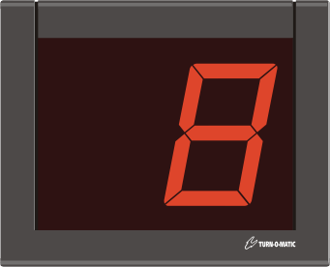
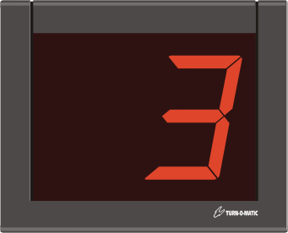
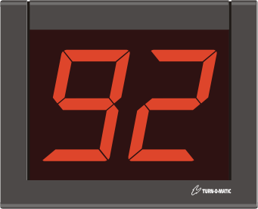
Max = 220
Indicators + SL900 / system
MASTER
START pack L3
TOM-Net
data cable
PLUS pack with 3-digit Indicator INR903 optional. SC900, D900A3, Indicator and K900 power supply not shown.
Keypad
K900
System Controller SC900
PLUS pack D900A3
PLUS pack INR902
PLUS pack K900
PLUS pack
K900
Max = 30
K900 / system
PLUS pack INR902
PLUS pack INR902
PLUS pack INR902
DSN Indicator
HCW Indicator
AWT Indicator

- Indicator PLUS packs include plug-in Power supply and plug-in TOM-Net data cable.
- Advised waiting time info; Advised Waiting Time (AWT) Indicator displays the currently calculated wait for service using the rolling average of the last 10 customers served. The calculated Advised Waiting Time can be manually changed at any time from a K900.
- Last dispensed ticket number info; Dispensed Service Number (DSN) Indicator displays the last dispensed ticket number.
- Customers waiting info; Help Customers Waiting (HCW) Indicator displays the number of customers waiting for service.
- Customer waiting time option; HCW Indicator can be set to display customer waiting time in minutes or in seconds.

L3 Par expansion option – service position help call Indicator
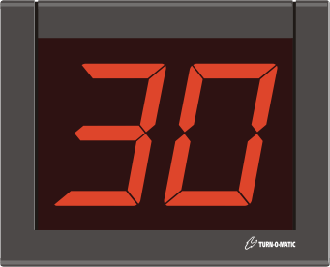
PLUS pack INR902
MASTER
Dispenser D900A3
START pack L3
TOM-Net
data cable
PLUS pack with 3-digit Indicator INR903 optional.

SC900, D900A3, Indicator and K900 power supply not shown.
Keypad
K900
System Controller SC900
PLUS pack D900A3
PLUS pack CDR22
PLUS pack K900
SP1
PLUS pack K900
SP30 max
Max = 30
K900 / system
Max = 220
Indicators + SL900 / system
HSP
Indicator

- Indicator PLUS pack includes plug-in Power supply and plug-in TOM-Net data cables.
- Call for help to Service Point (SP); pressing the ! (Attention) key on a K900 displays the K900’s SP number (or SP alias number if set) on the Help Service Position (HSP) Indicator. K900 displays ‘H.nnn’ (nnn = last called number) to show that it is in HSP mode, during which normal operation is suspended. Pressing the ! key again exits HSP mode and stops display of the SP number on the HSP Indicator.
- Urgent call for Help to SP: holding down the ! key on a K900 for 3+ seconds displays the K900’s SP number or alias number continuously blinking on the HSP Indicator. K900 display blinks ‘H.nnn’ to show that it is in urgent HSP mode. Pressing the ! key again exits HSP mode and stops display of the SP number on the HSP Indicator.

V3 installation, connections and address setting

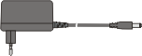
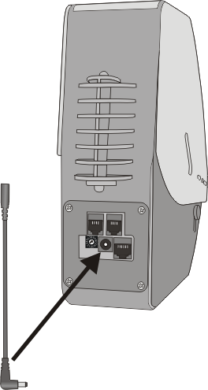
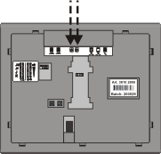
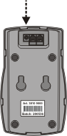
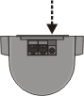
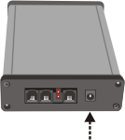
Power connections
12VAC/15VDC
DC plug 2.5 mm
(use only TOM power supplies)
Dispenser
D900A3
Use power extension with angled plug included with dispenser.
Indicator IN902 / 903
On back of Indicator, at the top
Keypad
K900
On bottom of K900
Signal Lamp
SL900
On top
of SL900
System Controller
SC900
On LED indicator end of SC900

I/O connections
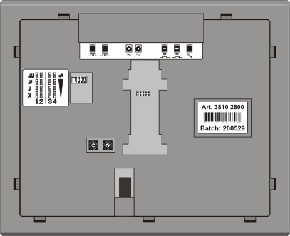
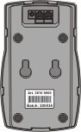


RJ10 modular plug
(use only TOM data cables)
Indicator IN902 / 903
TOM-Net
data I/O
Push Button (- / +)
Cascade In
Cascade Out
Keypad
K900
TOM-Net
data I/O
Signal Lamp
SL900
TOM-Net
data I/O
System Controller
SC900
TOM-Net
data I/O
TOM-Net
data I/O
Dispenser
D900A3

Setting TOM-Net addresses
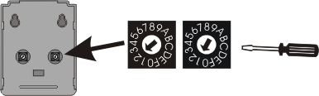
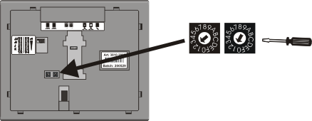
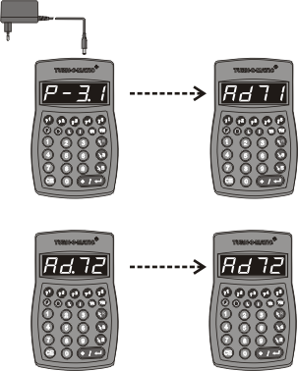
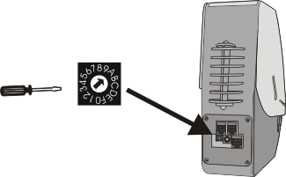
Rotate address switch with a small screwdriver.
Signal Lamp
SL900
Indicator IN902 / 903
Rotate address switches with a small screwdriver.
Connect power. Hold down L key during startup sequence.
Change address
+ with ENTER key
or – with R key.
Hold down L key for 3+ seconds to save new address setting (takes affect on new power ON).
Keypad
K900
Rotate address switch with a small screwdriver.
Dispenser
D900A3

V3 installation, TOM-Net address settings

S3 base systems, address settings
Indicator INR902
Dispenser D900

Counter Stand
(CS) optional
START pack S32 PB CS
Push Button PB900 (-)
Push Button PB900 (-)
Wireless Push Button RFv2
Indicator INR902 RF
Dispenser D900

Counter Stand
(CS) optional
START pack S32 RF CS
Hard-wired Push Button
Wireless Push Button
START packs with 3-digit Indicator INR903 optional.

Indicator power supply not shown.
TOM-Net addresses are pre-set for START pack units:

Indicator = 51

S3 expansions, hard-wired Push Button, address settings
MASTER
Dispenser D900

Counter Stand
(CS) optional
START pack S32 PB CS
Push Button PB900 (-)
Push Button PB900 (-)
TOM-Net
data cable
PLUS pack INR902
SLAVE
PLUS pack INR902
SLAVE
PB900 (+) plug-in set
PB900 (+) plug-in set
Max = 256
Indicators / system
Max = no limit
PLUS packs with 3-digit Indicator INR903 optional.

Indicator power supply not shown.
TOM-Net addresses are pre-set for START pack units:

Indicator = 51 (MASTER)
Set TOM-Net addresses for PLUS pack units:

Indicator = 50 (SLAVE)

S3 expansions, wireless Push Button, address settings
MASTER
Dispenser D900

Counter Stand
(CS) optional
START pack S32 RF CS
TOM-Net
data cable
PLUS pack INR902
SLAVE
PLUS pack INR902
SLAVE
Wireless Push Button
Wireless Push Button RFv2
Max = 256
Indicators / system
Max = 15 PB / system
PLUS packs with 3-digit Indicator INR903 optional.

Indicator power supply not shown.
Wireless Push Button
TOM-Net addresses are pre-set for START pack units:

Indicator = 51 (MASTER)
Set TOM-Net addresses for PLUS pack units:

Indicator = 50 (SLAVE)

M3 base system, address settings

MASTER
Dispenser D900

Counter Stand
(CS) optional
START pack M32 CS
TOM-Net
data cable
START pack with 3-digit Indicator INR903 optional.

Indicator and K900 power supply not shown.
Keypad
K900
TOM-Net addresses are pre-set for START pack units:

Indicator = 50
K900 = 71

M3 expansions, address settings
TOM-Net addresses are pre-set for START pack units:

Indicator = 50
K900 = 71

Dispenser D900

Counter Stand
(CS) optional
START pack M32 CS
TOM-Net
data cable
Keypad
K900
MASTER
TOM-Net
data cable
PLUS pack INR902
PLUS pack INR902
PLUS pack K900
Max = 241
Indicators / system
Max = 15
K900 / system
PLUS packs with 3-digit Indicator INR903 optional.

Indicator and K900 power supply not shown.
PLUS pack K900
Set TOM-Net addresses before installation for PLUS pack units:

Indicator = 50K900 (Nr.6) = 76K900 (Nr.11) = 7B
K900 (Nr.2) = 72K900 (Nr.7) = 77K900 (Nr.12) = 7C
K900 (Nr.3) = 73K900 (Nr.8) = 78K900 (Nr.13) = 7D
K900 (Nr.4) = 74K900 (Nr.9) = 79K900 (Nr.14) = 7E
K900 (Nr.5) = 75K900 (Nr.10) = 7AK900 (Nr.15) = 7F

NOTE: NO DUPLICATE K900 ADDRESSES ALLOWED!

M3 Par (parallel service points), address settings

MASTER
Dispenser D900

Counter Stand
(CS) optional
START pack M32 Par CS
TOM-Net
data cable
START pack with 3-digit Indicator INR903 optional.

Indicator and K900 power supply not shown.
Keypad
K900
CDR22
(Customer
Direction display)
SP1
SP2
TOM-Net addresses are pre-set for START pack units:

Indicator CD-Nr = 50
Indicator CD-SP = 60
K900 SP1 = 71
K900 SP2 = 72

M3 Par expansions, address setttings
MASTER
Dispenser D900

Counter Stand
(CS) optional
START pack M32 Par CS
TOM-Net
data cable
Keypad
K900
SP1
SP2
TOM-Net
data cable
PLUS pack CDR22
PLUS pack K900
Max = 241
Indicators / system
Max = 15
K900 / system
PLUS packs with 3-digit Indicator INR903 optional.

Indicator and K900 power supply not shown.
PLUS pack K900
SP3
SP15 Max
TOM-Net addresses are pre-set for START pack units:

Indicator CD-Nr = 50
Indicator CD-SP = 60
K900 SP1 = 71
K900 SP2 = 72

Set TOM-Net addresses before installation for PLUS pack units:

Indicator CD-Nr = 50K900 SP6 = 76K900 SP11 = 7B
Indicator CD-SP = 60K900 SP7 = 77K900 SP12 = 7C
K900 SP3 = 73K900 SP8 = 78K900 SP13 = 7D
K900 SP4 = 74K900 SP9 = 79K900 SP14 = 7E
K900 SP5 = 75K900 SP10 = 7AK900 SP15 = 7F

NOTE: NO DUPLICATE K900 ADDRESSES ALLOWED!

M3 Par expansion option – SP Indicators, address settings
MASTER
Dispenser D900

Counter Stand
(CS) optional
START pack M32 Par CS
Keypad
K900
SP1
SP2
TOM-Net
data cable
PLUS pack INR902
PLUS packs with 3-digit Indicator INR903 optional.

Indicator and K900 power supply not shown.
PLUS pack INR902
SP1
SP2
Set TOM-Net addresses before installation for PLUS pack units:

Indicator SP1 = 51Indicator SP4 = 54Indicator SP7 = 57Indicator SP10 = 5AIndicator SP13 = 5D
Indicator SP2 = 52Indicator SP5 = 55Indicator SP8 = 58Indicator SP11 = 5BIndicator SP14 = 5E
Indicator SP3 = 53Indicator SP6 = 56Indicator SP9 = 59Indicator SP12 = 5CIndicator SP15 = 5F

M3 Par expansion option – SL900 service position lamps, address settings
MASTER
Dispenser D900

Counter Stand
(CS) optional
START pack M32 Par CS
Keypad
K900
SP1
SP2
TOM-Net
data cable
PLUS pack SL900x2
Indicator, K900 and SL900 power supply not shown.
SP1
SP2
Set TOM-Net addresses before installation for PLUS pack units:

SL900 SP1 = 91SL900 SP4 = 94SL900 SP7 = 97SL900 SP10 = 9ASL900 SP13 = 9D
SL900 SP2 = 92SL900 SP5 = 95SL900 SP8 = 98SL900 SP11 = 9BSL900 SP14 = 9E
SL900 SP3 = 93SL900 SP6 = 96SL900 SP9 = 99SL900 SP12 = 9CSL900 SP15 = 9F

L3 base system, address settings

MASTER
Dispenser D900A3
START pack L3
TOM-Net
data cable
PLUS pack with 3-digit Indicator INR903 optional.

SC900, D900A3, Indicator and K900 power supply not shown.
Keypad
K900
System Controller SC900
PLUS pack D900A3
PLUS pack INR902
PLUS pack K900
Set TOM-Net addresses before installation for PLUS pack units:

Indicator = C1
K900 = 71
D900A3 = A

L3 expansions, address settings
PLUS pack with 3-digit Indicator INR903 optional. SC900, D900A3, Indicator, SL900 and K900 power supply not shown.
Max = 220
Indicators + SL900 / system
MASTER
START pack L3
TOM-Net
data cable
Keypad
K900
System Controller SC900
PLUS pack D900A3
PLUS pack INR902
PLUS pack K900
PLUS pack SL900x2
PLUS pack
K900
Max = 30
K900 / system
PLUS pack INR902
PLUS pack INR902
Recall Service Indicator
HCW Alert Signal
Service Indicator Extension
Set TOM-Net addresses before installation for PLUS pack units:

Service Indicator = C1Recall Service Indicator = CAHCW Alert Signal = B1

K900 (Nr.2) = 72K900 (Nr.8) = 78K900 (Nr.14) = 7EK900 (Nr.20) = 85 K900 (Nr.26) = 8B
K900 (Nr.3) = 73K900 (Nr.9) = 79K900 (Nr.15) = 7FK900 (Nr.21) = 86K900 (Nr.27) = 8C
K900 (Nr.4) = 74K900 (Nr.10) = 7AK900 (Nr.16) = 81K900 (Nr.22) = 87K900 (Nr.28) = 8D
K900 (Nr.5) = 75K900 (Nr.11) = 7BK900 (Nr.17) = 82K900 (Nr.23) = 88K900 (Nr.29) = 8E
K900 (Nr.6) = 76K900 (Nr.12) = 7CK900 (Nr.18) = 83K900 (Nr.24) = 89K900 (Nr.30) = 8F
K900 (Nr.7) = 77K900 (Nr.13) = 7DK900 (Nr.19) = 84K900 (Nr.25) = 8A

NOTE: NO DUPLICATE K900 ADDRESSES ALLOWED!

L3 multiple services, address settings

MASTER
START pack L3
TOM-Net
data cable
PLUS packs with 3-digit Indicator INR903 optional. SC900, D900A3, Indicator, SL900 and K900 power supply not shown.
Keypad
K900
System Controller SC900
PLUS pack D900A3
PLUS pack INR902
PLUS pack K900
PLUS pack D900A3
PLUS pack INR902
PLUS pack SL900x2
Service ‘A’
PLUS pack
K900
Max = 30
K900 / system
Max = 5
D900A3 / system
Service ‘B’
Service ‘B’
Service ‘A’
Service ‘A’
Service ‘B’
Max = 220
Indicators + SL900 / system
HCW Alert Signal
Set TOM-Net addresses before installation for PLUS pack units:

Service ‘A’Service ‘B’Service ‘C’Service ‘D’Service ‘E’
D900A3 = A D900A3 = B D900A3 = CD900A3 = DD900A3 = E
Service Indicator = C1Service Indicator = C2Service Indicator = C3Service Indicator = C4Service Indicator = C5
Recall Indicator = CARecall Indicator = CBRecall Indicator = CCRecall Indicator = CDRecall Indicator = CE
HCW Alert Signal = B1HCW Alert Signal = B2HCW Alert Signal = B3HCW Alert Signal = B4HCW Alert Signal = B5

L3 Par (parallel service points), address settings
MASTER
Dispenser D900A3
START pack L3
TOM-Net
data cable
PLUS pack with 3-digit Indicator INR903 optional.

SC900, D900A3, Indicator and K900 power supply not shown.
Keypad
K900
System Controller SC900
PLUS pack D900A3
PLUS pack CDR22
PLUS pack K900
SP1
PLUS pack K900
SP2
SP30 max
PLUS pack K900
Max = 30
K900 / system
Max = 220
Indicators + SL900 / system
Set TOM-Net addresses before installation for PLUS pack units:

Indicator CD-Nr = C1Indicator CD-SP = D1

K900 SP1 = 71K900 SP7 = 77K900 SP13 = 7DK900 SP19 = 84K900 SP25 = 8A
K900 SP2 = 72K900 SP8 = 78K900 SP14 = 7EK900 SP20 = 85K900 SP26 = 8B
K900 SP3 = 73K900 SP9 = 79K900 SP15 = 7FK900 SP21 = 86K900 SP27 = 8C
K900 SP4 = 74K900 SP10 = 7AK900 SP16 = 81K900 SP22 = 87K900 SP28 = 8D
K900 SP5 = 75K900 SP11 = 7BK900 SP17 = 82K900 SP23 = 88K900 SP29 = 8E
K900 SP6 = 76K900 SP12 = 7CK900 SP18 = 83K900 SP24 = 89K900 SP30 = 8F

NOTE: NO DUPLICATE K900 ADDRESSES ALLOWED!

L3 Par expansion option – SP Indicator, address settings
PLUS pack INR902
PLUS pack INR902
SP1
MASTER
Dispenser D900A3
START pack L3
TOM-Net
data cable
PLUS pack with 3-digit Indicator INR903 optional.

SC900, D900A3, Indicator and K900 power supply not shown.
Keypad
K900
System Controller SC900
PLUS pack D900A3
PLUS pack CDR22
PLUS pack K900
SP1
PLUS pack K900
SP30 max
Max = 30
K900 / system
Max = 220
Indicators + SL900 / system
SP30 max
Set TOM-Net addresses before installation for PLUS pack units:

Indicator SP1 = 51Indicator SP7 = 57Indicator SP13 = 5DIndicator SP19 = 64Indicator SP25 = 6A
Indicator SP2 = 52Indicator SP8 = 58Indicator SP14 = 5EIndicator SP20 = 65Indicator SP26 = 6B
Indicator SP3 = 53Indicator SP9 = 59Indicator SP15 = 5FIndicator SP21 = 66Indicator SP27 = 6C
Indicator SP4 = 54Indicator SP10 = 5AIndicator SP16 = 61Indicator SP22 = 67Indicator SP28 = 6D
Indicator SP5 = 55Indicator SP11 = 5BIndicator SP17 = 62Indicator SP23 = 68Indicator SP29 = 6E
Indicator SP6 = 56Indicator SP12 = 5CIndicator SP18 = 63Indicator SP24 = 69Indicator SP30 = 6F

L3 Par expansion option – SL900 service position lamps, address settings
SP1
MASTER
Dispenser D900A3
START pack L3
TOM-Net
data cable
PLUS pack with 3-digit Indicator INR903 optional.

SC900, D900A3, Indicator, SL900 and K900 power supply not shown.
Keypad
K900
System Controller SC900
PLUS pack D900A3
PLUS pack CDR22
PLUS pack K900
SP1
PLUS pack K900
SP30 max
Max = 30
K900 / system
Max = 220
Indicators + SL900 / system
SP30 max
PLUS pack SL900x2
Set TOM-Net addresses before installation for PLUS pack units:

SL900 SP1 = 91SL900 SP7 = 97SL900 SP13 = 9DSL900 SP19 = A4SL900 SP25 = AA
SL900 SP2 = 92SL900 SP8 = 98SL900 SP14 = 9ESL900 SP20 = A5SL900 SP26 = AB
SL900 SP3 = 93SL900 SP9 = 99SL900 SP15 = 9FSL900 SP21 = A6SL900 SP27 = AC
SL900 SP4 = 94SL900 SP10 = 9ASL900 SP16 = A1SL900 SP22 = A7SL900 SP28 = AD
SL900 SP5 = 95SL900 SP11 = 9BSL900 SP17 = A2SL900 SP23 = A8SL900 SP29 = AE
SL900 SP6 = 96SL900 SP12 = 9CSL900 SP18 = A3SL900 SP24 = A9SL900 SP30 = AF

L3 expansion options – info Indicators, address settings
Max = 220
Indicators + SL900 / system
MASTER
START pack L3
TOM-Net
data cable
PLUS pack with 3-digit Indicator INR903 optional. SC900, D900A3, Indicator and K900 power supply not shown.
Keypad
K900
System Controller SC900
PLUS pack D900A3
PLUS pack INR902
PLUS pack K900
PLUS pack
K900
Max = 30
K900 / system
PLUS pack INR902
PLUS pack INR902
PLUS pack INR902
DSN Indicator
HCW Indicator
AWT Indicator
Set TOM-Net addresses before installation for PLUS pack units:

Service ‘A’Service ‘B’Service ‘C’Service ‘D’Service ‘E’
AWT Indicator = 3A AWT Indicator = 3B AWT Indicator = 3C AWT Indicator = 3D AWT Indicator = 3E
DSN Indicator = 31DSN Indicator = 32DSN Indicator = 33DSN Indicator = 34DSN Indicator = 35
HCW Indicator = BAHCW Indicator = BBHCW Indicator = BCHCW Indicator = BDHCW Indicator = BE

L3 Par expansion option – service position help call Indicator, address setting

PLUS pack INR902
MASTER
Dispenser D900A3
START pack L3
TOM-Net
data cable
PLUS pack with 3-digit Indicator INR903 optional.

SC900, D900A3, Indicator and K900 power supply not shown.
Keypad
K900
System Controller SC900
PLUS pack D900A3
PLUS pack CDR22
PLUS pack K900
SP1
PLUS pack K900
SP30 max
Max = 30
K900 / system
Max = 220
Indicators + SL900 / system
HSP
Indicator
Set TOM-Net addresses for PLUS pack units:

HSP Indicator = B9

Approximate installation times for V3 START and PLUS packs
NOTE: Approximate installation times are assuming that usable mains power outlets are available for direct plug-in of power supplies. Time for training service personnel on system operation is not included; normally, approx. training time = 1 – 2 hours for S3 system, 2 – 3 hours for M3 system and 3 – 5 hours for L3 system.

System | START packs | Approximate installation  time in hours | PLUS packs | Approximate installation time in hours
S3 | S32 PB, S33 PB (with or w/o CS) | 1 – 2 | IN902 X1, IN903 X1 | 1 – 2
S3 | S32 RF, S33 RF (with or w/o CS) | ½ - 1 | IN902 X2, IN903 X2 | 2 – 3
S3 | S323 PB | 2 – 3 | IN902 X2CB, IN903 X2CB | 3 – 4
S3 | S323 PB CB | 3 – 4 | IN902 X3CB, IN903 X3CB | 3 – 4
S3 | S323 RF | 1½ - 2
S3 | S323 RF CB | 2½ - 3
M3 | M32, M33 (with or w/o CS) | 1 – 2 | IN902 X1, IN903 X1 | 1 – 2
M3 | M32 Par, M33 Par | 3 – 4 | IN902 X2, IN903 X2 | 2 – 3
M3 |  |  | IN902 X2CB, IN903 X2CB | 3 – 4
M3 |  |  | IN902 X3CB, IN903 X3CB | 3 – 4
M3 |  |  | CD22, CD32 | 2 – 3
M3 |  |  | K900 | 1 – 2
M3 |  |  | SL900 x2 | 2 – 3
L3 | L3 incl. system setup & TOV install | 4 – 5 | D900A3 | 1 – 2
L3 |  |  | K900 | 1 – 2
L3 |  |  | IN902 X1, IN903 X1 | 1 – 2
L3 |  |  | IN902 X2CB, IN903 X2CB | 3 – 4
L3 |  |  | IN902 X3CB, IN903 X3CB | 3 – 4
L3 |  |  | CD22, CD32 | 2 – 3
L3 |  |  | K900 | 1 – 2
L3 |  |  | SL900 x2 | 2 – 3

V3 system messages

Indicator error messages
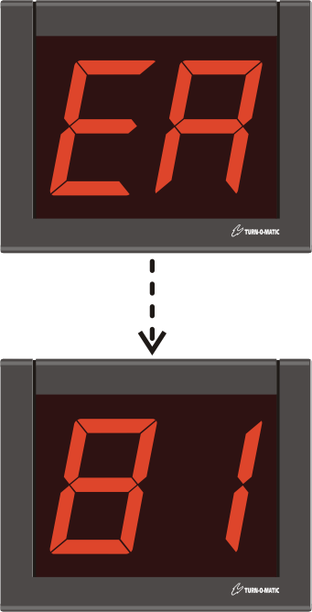
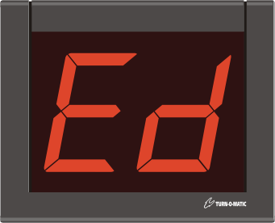
EA (Error Address)

Indicator has been set to an invalid TOM-Net address. This message applies to all systems and is displayed on Indicator startup.

After briefly displaying the ‘EA’ message, the Indicator then briefly displays the invalid address setting (example = 81). This display sequence then cycles continuously.

Corrective actions:
Change the Indicator address to a valid TOM-Net Indicator address.
If the Indicator is set to a valid TOM-Net address, the rotary address switches or internal connections are faulty. Replace the Indicator.

Ed (Error Duplicate)

There are duplicate MASTER Indicators on the system, i.e. more than one Indicator set to Address 51.

This message only applies to the system S3 and is displayed on Indicator startup.

Corrective actions:
Change any duplicate MASTER Indicator addresses to Address 50.

K900 error messages

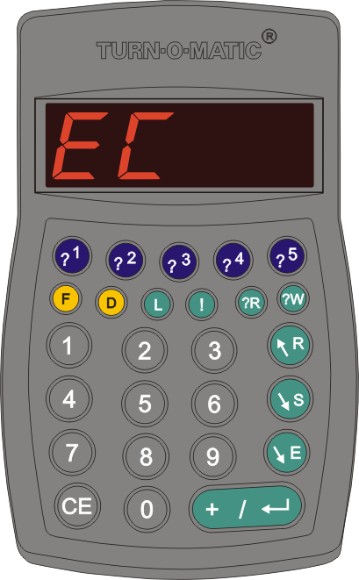
EC (Error Communication)

The ‘EC’ message applies to both systems M3 and L3.

If ‘EC’ is displayed on system startup, more than one K900 has been set to the same address.

Corrective action:
Check for duplicate K900 address settings and change to a non-duplicate address.

If ‘EC’ is displayed during system operation, the message can be removed on the K900 displaying the message by holding down the F key 3+ seconds to display ‘F-00’ and pressing the ENTER key.

If the ‘EC’ message reappears:
Check for faulty TOM-Net data cable connections and replace any suspect data cables.

If the ‘EC’ message does not reappear:
A unit on the system has been powered OFF, most notably a dispenser D900A3. When the D900A3 is powered ON again, the dispenser will be Off-line and the message ‘$.doL’ ($ = service ‘A, b, C, d or E’) will be displayed.
A unit has been disconnected and reconnected to the system (hot swapped).
There are duplicate Indicator addresses on an L3 system, which is allowed. In scanning for active devices, it can happen that the SC900 receives answers from both Indicators at almost the same time and the misread data is seen as an ‘EC’ error.

K900 warning messages, L3 system
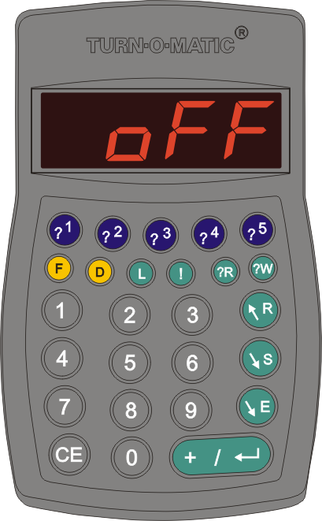
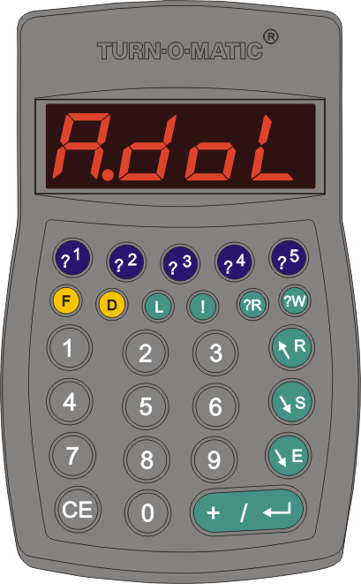
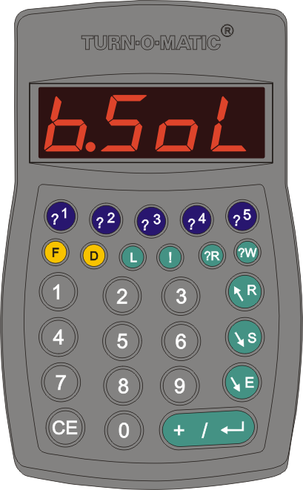
oFF (K900 logged OFF)

The K900 is not logged ON to a Service.

Hold down the L key 3+ seconds to open the logon process. Press the ENTER key to step through the selections ‘Aon’, ‘bon’, ‘Con’, ‘don’ and ‘Eon’ Service Types or ‘LoFF’ to log the K900 OFF the system.

Hold down the L key 3+ seconds to activate the selection.

$.doL (Dispenser OFF line)

The dispenser for the $=Service Type (example ‘A’) is not ON line.

Press the D key. K900 displays A_ _ _ (example) for input of start ticket number. Key in the start ticket number (all 3 digits) and press the D key again. K900 displays A.- - - showing that it is ready for normal operation.

Note: Pressing the D key without input of a ticket number will assume the last dispensed number as the start number.

$.SoL (Service OFF line)

There are customers waiting for first service call in $=Service Type (example ‘B’) and no K900 is logged ON to that Service.

Hold down the L key 3+ seconds to open the logon process. Press the ENTER key to step through the selections ‘Aon’, ‘bon’, ‘Con’, ‘don’ and ‘Eon’ Service Types. Select the OFF line Service Type and hold down the L key 3+ seconds to log ON.

K900 warning messages, L3 system
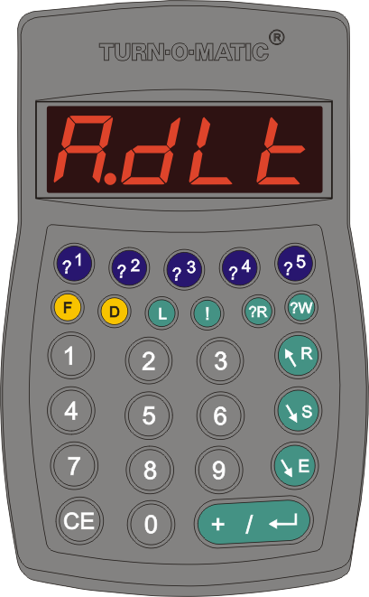
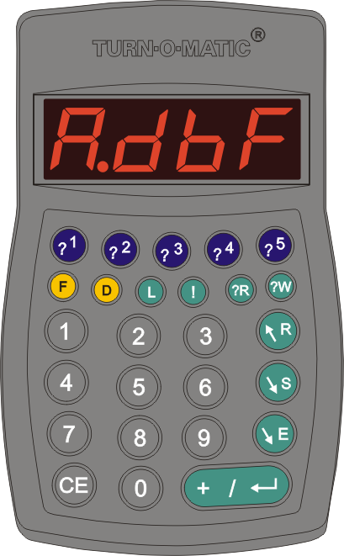
$.dLt (Dispenser low ticket level)

The dispenser for the $=Service Type (example ‘A’) has reached the tickets remaining alert level (set with F43, pre-set default = 100 tickets remaining).

To change ticket roll, hold down the D key 3+ seconds to put the dispenser OFF line.

Set in the new ticket roll and take a ticket before closing the dispenser cover. Press the D key and input this ticket number for the start ticket number. Press the D key to put the dispenser ON line.
$.dbF (Data buffer full)

The active service buffer for the $=Service Type (example ‘A’) is nearly full, nearing the maximum of 250 customers waiting for first call or recall service.

When the data buffer is full, new customer numbers will overwrite the oldest numbers in the buffer.

Notes: If there are many unwanted recall numbers, set F24 SAVE type to Manual Save (default) instead of Auto Save.

Recall numbers can be scrolled and optionally removed when they are displayed on the K900 by pressing the E key to END service.

Note:

These warning messages can be removed from the K900 display.

Hold down the F key 3+ seconds until the K900 displays F-00. Press the ENTER key to remove the message display.

V3 products in V2 system configurations

Direct 900 – replacement Indicator
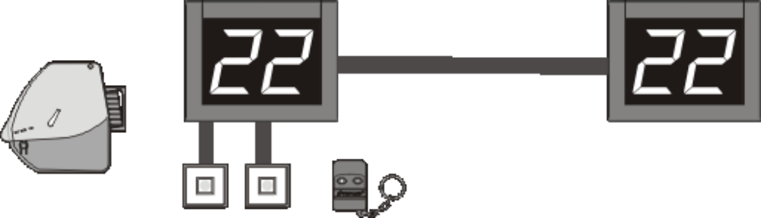
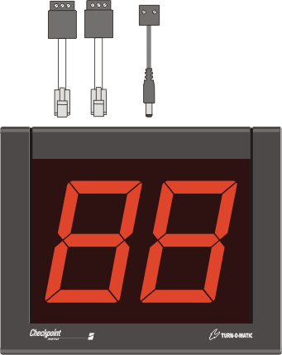
Indicator INR902 V2service
MASTER
TOM-Net
data cable
SLAVE

- Indicator V2service pack includes plug-in V2 cable adapters for connecting existing V2 power supply and TOM-Net data cables to the V2service Indicator.
- For replacement of a V2 MASTER Indicator, set the V2service Indicator address = 21.
- For replacement of a V2 MASTER Indicator with Wireless Push Button RFv2, install the RFv2 Receiver on the V2service Indicator.
- For replacement of a V2 SLAVE Indicator, set the V2service Indicator address = 20.
- Connect existing power cable to the V2service Indicator with the ‘Connection adapter V2 cable - V3 DC plug’.
- Connect the existing push button cable to the V2service Indicator with the ‘Connection adapter V2 cable - V3 RJ10 plug’. Connect one lead to Pin 2 – Signal and the other lead to Pin 3 - GND.
- Connect the existing data cable to the V2service Indicator with the ‘Connection adapter V2 cable - V3 RJ10 plug’. Connect the WHITE lead to Pin2-Signal A, brown lead to Pin3-Signal B and the cable shield to Pin1-GND.

Direct 900 – expansion Indicator
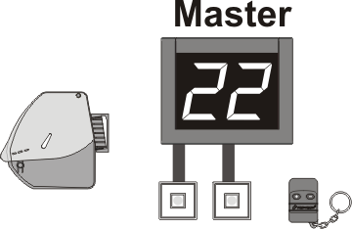
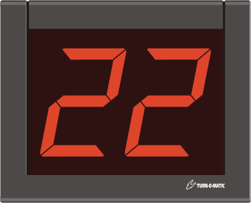
TOM-Net
data cable
PLUS pack INR902
PLUS packs with 3-digit Indicator INR903 optional.

Indicator power supply not shown.

- Indicator PLUS packs include plug-in Power supply and plug-in TOM-Net data cable.
- Extended display of called service number; PLUS pack SLAVE Indicators display same number as the START pack MASTER Indicator.
- Set PLUS pack expansion Indicator to address = 20.
- To connect the PLUS pack TOM-Net data cable to the V2 Indicator, cut off the RJ10 plug on the V2 Indicator end of the cable. Then, connect the data cable leads to the COMMS connector on the V2 Indicator as follows; WHITE lead to A, BROWN lead to B and the cable shield to the shield ground (upside down T).

Direct 900 Parallel – replacement Indicator

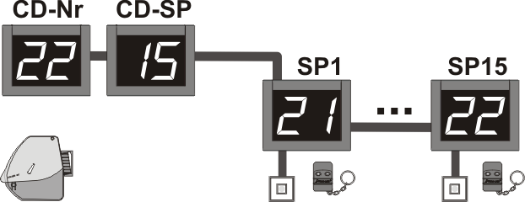
Indicator INR902 V2service

- Indicator V2service pack includes plug-in V2 cable adapters for connecting existing V2 power supply and TOM-Net data cables to the V2service Indicator.
- For replacement of a V2 CD-Nr Indicator, set V2service Indicator address = 20.
- For replacement of a V2 CD-SP Indicator, set V2service Indicator address = 30.
- For replacement of V2 Service Point (SP) Indicators, set V2service Indicator address as follows:
SP1 = 21 SP2 = 22 SP3 = 23 SP4 = 24 SP5 =25 SP6 = 26 SP7 = 27 SP8 = 28
SP9 = 29 SP10 = 2A SP11 = 2B SP12 =2C SP13 = 2D SP14 = 2E SP15 = 2F
NOTE: Duplicate addresses are not allowed.
- For replacement of a V2 SP Indicator with Wireless Push Button RFv2, install the RFv2 Receiver on the V2service Indicator.
- Connect existing power cable to the V2service Indicator with the ‘Connection adapter V2 cable - V3 DC plug’.
- Connect the existing data cable to the V2service Indicator with the ‘Connection adapter V2 cable - V3 RJ10 plug’. Connect the WHITE lead to Pin2-Signal A, brown lead to Pin3-Signal B and the cable shield to Pin1-GND.

Direct 900 Parallel – expansion Indicator
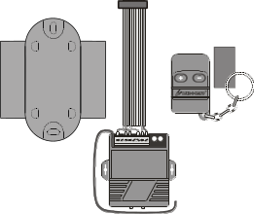
TOM-Net
data cable
PLUS pack INR902
PLUS packs with 3-digit Indicator INR903 optional.

Indicator power supply not shown.
PB900 (+) plug-in set
Wireless Push Button set RFv2

- Indicator PLUS packs include plug-in Power supply and plug-in TOM-Net data cable.
- Connect either the PB900 plug-in set OR install the Wireless Push Button set RFv2 on the PLUS pack Indicator.
- For expansion of Service Point Indicators, set PLUS pack Indicator address as follows:
SP1 = 21 SP2 = 22 SP3 = 23 SP4 = 24 SP5 =25 SP6 = 26 SP7 = 27 SP8 = 28
SP9 = 29 SP10 = 2A SP11 = 2B SP12 =2C SP13 = 2D SP14 = 2E SP15 = 2F
NOTE: Duplicate addresses are not allowed.
- To connect the PLUS pack TOM-Net data cable to the V2 Indicator, cut off the RJ10 plug on the V2 Indicator end of the cable. Then, connect the data cable leads to the COMMS connector on the V2 Indicator as follows; WHITE lead to A, BROWN lead to B and the cable shield to the shield ground (upside down T).

Select 900 – replacement Indicator

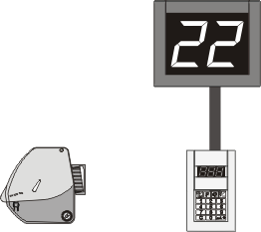
Indicator INR902 V2service

- Indicator V2service pack includes plug-in V2 cable adapters for connecting existing V2 power supply and TOM-Net data cables to the V2service Indicator.
- For replacement of a V2 Indicator, set the V2service Indicator address = 20.
- Connect existing power cable to the V2service Indicator with the ‘Connection adapter V2 cable - V3 DC plug’.
- Connect the existing data cable to the V2service Indicator with the ‘Connection adapter V2 cable - V3 RJ10 plug’. Connect the WHITE lead to Pin2-Signal A, brown lead to Pin3-Signal B and the cable shield to Pin1-GND.

Select 900 – expansion Indicator
TOM-Net
data cable
PLUS pack INR902
PLUS packs with 3-digit Indicator INR903 optional.

Indicator power supply not shown.

- Indicator PLUS packs include plug-in Power supply and plug-in TOM-Net data cable.
- Extended display of called service number; PLUS pack Indicator display same number as the V2 base Indicator.
- Set PLUS pack expansion Indicator to address = 20.
- To connect the PLUS pack TOM-Net data cable to the V2 Indicator, cut off the RJ10 plug on the connection to the V2 Indicator end of the cable. Then, connect the data cable leads to the COMMS connector on the V2 Indicator as follows; WHITE lead to A, BROWN lead to B and the cable shield to the shield ground (upside down T).

Select 900 – K900 replacement for C900


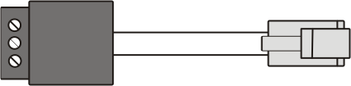
Keypad K900
Connection adapter V2 cable - V3 DC plug
Connection adapter V2 cable - V3 RJ10 plug

- Connect existing power cable to the K900 with the ‘Connection adapter V2 cable - V3 DC plug’.
- Set K900 address = 41. During K900 start-up, hold down the L key to open the address setting routing. Then, press the R key first to display the address selection 41. Hold down the L key to save the new address setting, which takes effect on next power ON.
- Connect the existing data cable to the K900 with the ‘Connection adapter V2 cable - V3 RJ10 plug’. Connect the WHITE lead to Pin2-Signal A, brown lead to Pin3-Signal B and the cable shield to Pin1-GND.

Select 900 Parallel – replacement Indicator

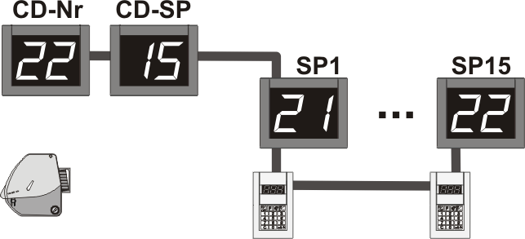
Indicator INR902 V2service

- Indicator V2service pack includes plug-in V2 cable adapters for connecting existing V2 power supply and TOM-Net data cables to the V2service Indicator.
- For replacement of a V2 CD-Nr Indicator, set the V2service Indicator address = 20.
- For replacement of a V2 CD-SP Indicator, set the V2service Indicator address = 30.
- For replacement of V2 Service Point (SP) Indicators, set the V2service Indicator address as follows:
SP1 = 21 SP2 = 22 SP3 = 23 SP4 = 24 SP5 =25 SP6 = 26 SP7 = 27 SP8 = 28
SP9 = 29 SP10 = 2A SP11 = 2B SP12 =2C SP13 = 2D SP14 = 2E SP15 = 2F
NOTE: Duplicate addresses are not allowed.
- Connect existing power cable to the V2service Indicator with the ‘Connection adapter V2 cable - V3 DC plug’.
- Connect the existing data cable to the V2service Indicator with the ‘Connection adapter V2 cable - V3 RJ10 plug’. Connect the WHITE lead to Pin2-Signal A, brown lead to Pin3-Signal B and the cable shield to Pin1-GND.

Select 900 Parallel – K900 replacement for C900
Keypad K900
Connection adapter V2 cable - V3 DC plug
Connection adapter V2 cable - V3 RJ10 plug

- Connect existing power cable to the K900 with the ‘Connection adapter V2 cable - V3 DC plug’.
- Set the K900 address. During K900 start-up, hold down the L key to open the address setting routing. Then, press the R key first to display the address selection starting with 41. Select the applicable Service Point address as follows:
SP1 = 41 SP2 = 42 SP3 = 43 SP4 = 44 SP5 =45 SP6 = 46 SP7 = 47 SP8 = 48
SP9 = 49 SP10 = 4A SP11 = 4B SP12 =4C SP13 = 4D SP14 = 4E SP15 = 4F
NOTE: Duplicate addresses are not allowed.
Hold down the L key to save the new address setting, which takes effect on next power ON.
- Connect the existing data cable to the K900 with the ‘Connection adapter V2 cable - V3 RJ10 plug’. Connect the WHITE lead to Pin2-Signal A, brown lead to Pin3-Signal B and the cable shield to Pin1-GND.
- NOTE: Service Point direction lamps cannot be used with K900 units in V2 systems.

Select 900 Parallel – expansion SP Indicator and K900
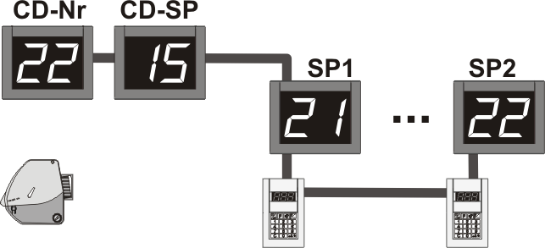
TOM-Net
data cable
PLUS pack INR902
PLUS packs with 3-digit Indicator INR903 optional.

Indicator and K900 power supply not shown.
SP15 max
PLUS pack K900

- Indicator PLUS packs include plug-in Power supply and plug-in TOM-Net data cable.
- For expansion of Service Point Indicators, set PLUS pack Indicator address as follows:
SP1 = 21 SP2 = 22 SP3 = 23 SP4 = 24 SP5 =25 SP6 = 26 SP7 = 27 SP8 = 28
SP9 = 29 SP10 = 2A SP11 = 2B SP12 =2C SP13 = 2D SP14 = 2E SP15 = 2F
NOTE: Duplicate addresses are not allowed.
- For expansion of Service Point keypads, set PLUS pack K900 address as follows:
SP1 = 41 SP2 = 42 SP3 = 43 SP4 = 44 SP5 =45 SP6 = 46 SP7 = 47 SP8 = 48
SP9 = 49 SP10 = 4A SP11 = 4B SP12 =4C SP13 = 4D SP14 = 4E SP15 = 4F
NOTE: Duplicate addresses are not allowed.
- To connect the PLUS pack TOM-Net data cable to the V2 Indicator, cut off the RJ10 plug on the V2 Indicator end of the cable. Then, connect the data cable leads to the COMMS connector on the V2 Indicator as follows; WHITE lead to A, BROWN lead to B and the cable shield to the shield ground (upside down T).
- NOTE: Service Point direction lamps cannot be used with K900 units in V2 systems.

Signal and Info 900 – D900A3 replacement for D900A or D90E

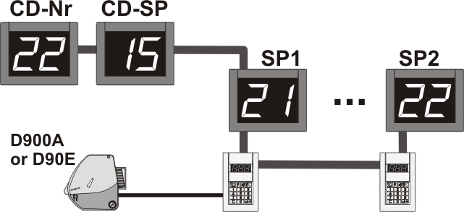
Dispenser pack D900A3
C900S or C900S-PC MASTER

- The Dispenser pack D900A3 includes a plug-in Power supply.
- Plug in the existing ‘Cable set D90E/D900A-C900’ to the RJ12 jack on the back of the D900A3 dispenser.
- NOTE: When replacing an existing D90E dispenser, consider the dispenser weight difference with the D900A3 weighing an additional 2.2 Kg (4.9 lb) more than the D90E. For example, the D900A3 cannot be installed on the Counter Stand.

Signal and Info 900 – replacement Indicator

C900S or C900S-PC MASTER
Indicator INR902 V2service

- Indicator V2service pack includes plug-in V2 cable adapters for connecting existing V2 power supply and TOM-Net data cables to the V2service Indicator.
- For replacement of a V2 CD-Nr Indicator or single common display, set the V2service Indicator address = 20.
- For replacement of a V2 CD-SP Indicator, set the V2service Indicator address = 30.
- For replacement of V2 Service Point (SP) Indicators, set the V2service Indicator address as follows:
SP1 = 21 SP2 = 22 SP3 = 23 SP4 = 24 SP5 =25 SP6 = 26 SP7 = 27 SP8 = 28
SP9 = 29 SP10 = 2A SP11 = 2B SP12 =2C SP13 = 2D SP14 = 2E SP15 = 2F
NOTE: Duplicate addresses are not allowed.
- Connect existing power cable to the V2service Indicator with the ‘Connection adapter V2 cable - V3 DC plug’.
- Connect the existing data cable to the V2service Indicator with the ‘Connection adapter V2 cable - V3 RJ10 plug’. Connect the WHITE lead to Pin2-Signal A, brown lead to Pin3-Signal B and the cable shield to Pin1-GND.

Signal and Info 900 – K900 replacement for C900
C900S or C900S-PC MASTER
Keypad K900
Connection adapter V2 cable - V3 DC plug
Connection adapter V2 cable - V3 RJ10 plug

- NOTE: The C900S or C900S-PC MASTER cannot be replaced with a K900 unit.
- Connect existing power cable to the K900 with the ‘Connection adapter V2 cable - V3 DC plug’.
- Set the K900 address. During K900 start-up, hold down the L key to open the address setting routing. Then, press the R key first to display the address selection starting with 41. Select the applicable Service Point address as follows:
SP1 = 41 SP2 = 42 SP3 = 43 SP4 = 44 SP5 =45 SP6 = 46 SP7 = 47 SP8 = 48
SP9 = 49 SP10 = 4A SP11 = 4B SP12 =4C SP13 = 4D SP14 = 4E SP15 = 4F
NOTE: Duplicate addresses are not allowed.
Hold down the L key to save the new address setting, which takes effect on next power ON.
- Connect the existing data cable to the K900 with the ‘Connection adapter V2 cable - V3 RJ10 plug’. Connect the WHITE lead to Pin2-Signal A, brown lead to Pin3-Signal B and the cable shield to Pin1-GND.
- NOTE: Service Point direction lamps cannot be used with K900 units in V2 systems.

Signal and Info 900 Parallel – expansion SP Indicator and K900
TOM-Net
data cable
PLUS pack INR902
PLUS packs with 3-digit Indicator INR903 optional.

Indicator and K900 power supply not shown.
SP15 max
PLUS pack K900
C900S or C900S-PC MASTER

- Indicator PLUS packs include plug-in Power supply and plug-in TOM-Net data cable.
- For expansion of Service Point Indicators, set PLUS pack Indicator address as follows:
SP1 = 21 SP2 = 22 SP3 = 23 SP4 = 24 SP5 =25 SP6 = 26 SP7 = 27 SP8 = 28
SP9 = 29 SP10 = 2A SP11 = 2B SP12 =2C SP13 = 2D SP14 = 2E SP15 = 2F
NOTE: Duplicate addresses are not allowed.
- For expansion of Service Point keypads, set PLUS pack K900 address as follows:
SP1 = 41 SP2 = 42 SP3 = 43 SP4 = 44 SP5 =45 SP6 = 46 SP7 = 47 SP8 = 48
SP9 = 49 SP10 = 4A SP11 = 4B SP12 =4C SP13 = 4D SP14 = 4E SP15 = 4F
NOTE: Duplicate addresses are not allowed.
- To connect the PLUS pack TOM-Net data cable to the V2 Indicator, cut off the RJ10 plug on the V2 Indicator end of the cable. Then, connect the data cable leads to the COMMS connector on the V2 Indicator as follows; WHITE lead to A, BROWN lead to B and the cable shield to the shield ground (upside down T).
- NOTE: Service Point direction lamps cannot be used with K900 units in V2 systems.

Signal and Info 900 – expansion with K900
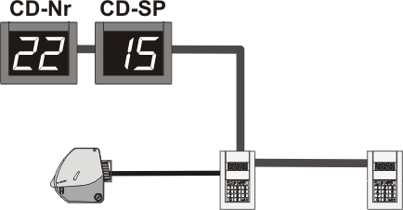
PLUS pack K900
Max = 15
C900 + K900 / system

- K900 PLUS packs include plug-in Power supply and plug-in TOM-Net data cable.
- For expansion of Service Point keypads, set PLUS pack K900 address as follows:
SP1 = 41 SP2 = 42 SP3 = 43 SP4 = 44 SP5 =45 SP6 = 46 SP7 = 47 SP8 = 48
SP9 = 49 SP10 = 4A SP11 = 4B SP12 =4C SP13 = 4D SP14 = 4E SP15 = 4F
NOTE: Duplicate addresses are not allowed.
- To connect the PLUS pack TOM-Net data cable to the end C900, cut off the RJ10 plug on the C900 end of the cable. Then, connect the data cable leads to the COMMS connector on the C900 as follows; WHITE lead to A, BROWN lead to B and the cable shield to the shield ground (upside down T).
- NOTE: Service Point direction lamps cannot be used with K900 units in V2 systems.

Connection adapter V2 cable - V3 RJ10 plug, pin out

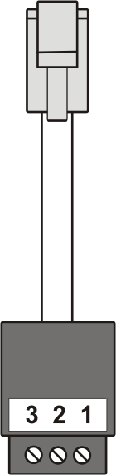
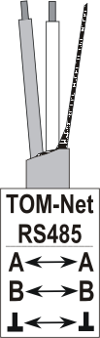

PIN MARKING

The output terminal pin marking for the RJ adapter should be as shown.

It is possible that cable adapters are incorrectly marked with the pin-marking label attached upside down.

For TOM-Net data cable connections, check the pin-marking label to be sure that it agrees with correct pin marking shown.
TOM-Net connection
Push Button connection

